**Use Address window in smart forms**

For the initial steps to create a smart form, please refer the previous demos.

1. Create a smart form.

2) Double click on Form Interface and declare the following parameter

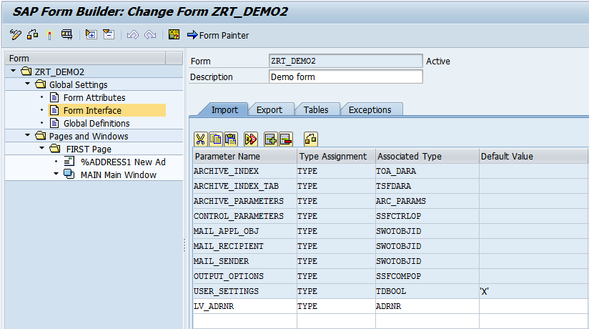

3) Right click on FIRSTPage.Main window.  
 Create-Address

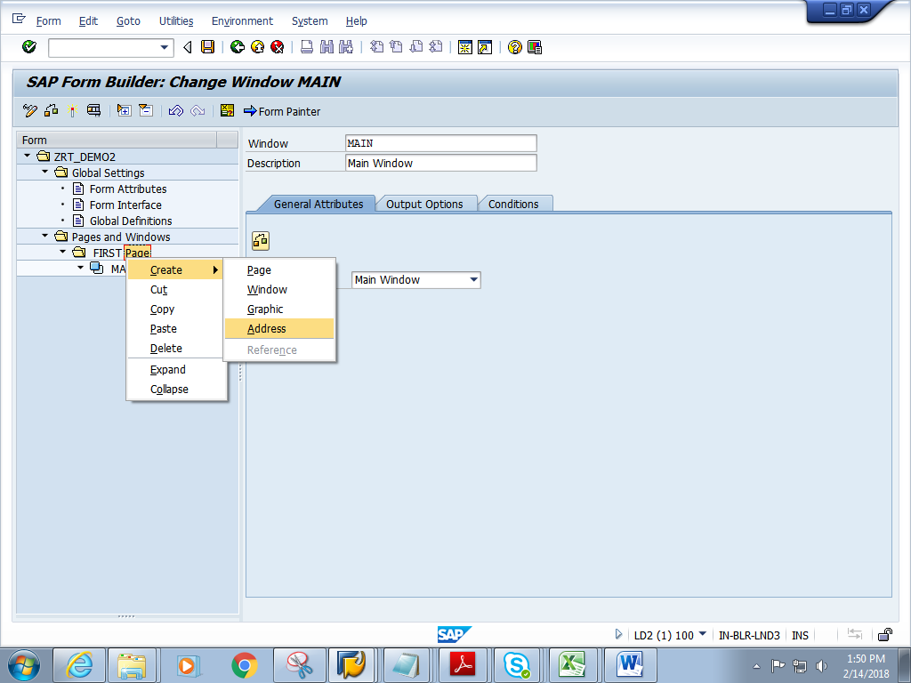

4) Double click on Address. Give Address number as shown below.

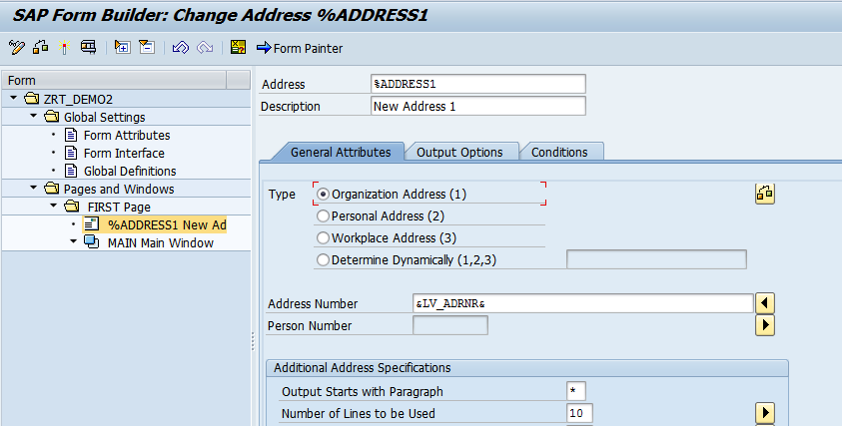

5) Click on Form Painter .Drag the Address and position it accordingly

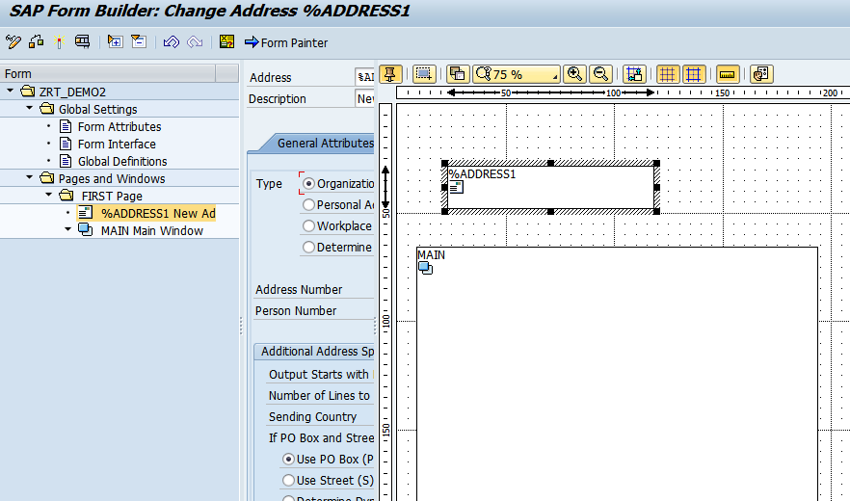

6) Save and activate the form.

7) Execute the form .Execute the function module. **Give the ADDRNR(any ADDRNR no from KNa1 table)**

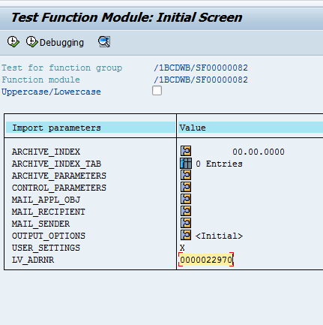

8) Click on Print preview

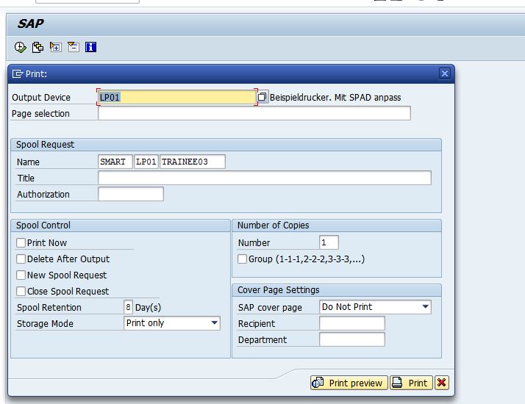

9) Expected output is as follows.

